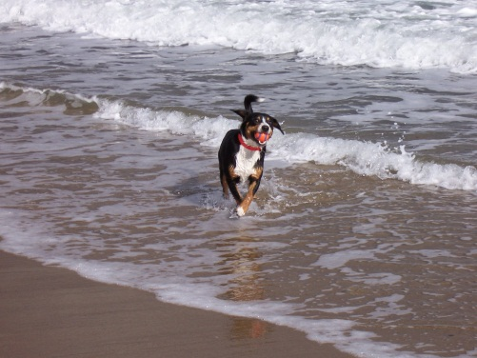 | Preserve Access to Scarborough’s  Parks & Beaches!

On October 2, the Town Council amended the Animal Control Ordinance so that:  - Dogs must always be on a leash less than 8 feet long when on Town beaches – even in the winter.  - Leashes are also always required on all Town parks, fields, streets and sidewalks – leaving no public space for a dog to even chase a ball.  - Overnight, Scarborough became one of the most dog-restrictive towns in Maine with dramatic negative consequences for many Town residents, businesses and seasonal visitors.  These changes were significantly more restrictive than any previously considered. The Council acted without notice and without allowing any public discussion. |  | What you can do to help…  - SIGN OUR PETITION to authorize a special election to overturn the amended ordinance.  - Ask friends & neighbors to sign the petition.  - Learn more about the issue and how to sign a petition by visiting our website at:  www.scarborodogs.com  - Watch for the exact date of the special election to overturn the amended ordinance in December!  Scarborough already had a thoughtful and  well-reasoned beach access policy. During the summer, it only allowed unleashed dogs under voice control on the beaches from 6-9am; after 5pm dogs were required to be on leashes. It considered the needs of beach goers, surfers, fishermen, dog owners and threatened wildlife – fairly and reasonably. Please help us restore that common-sense access to Scarborough’s beautiful beaches!  Dog Owners of Greater Scarborough  Join our mailing list at scarboro.dogs@gmail.com  10-08-13

